React-2

Assignment

Q1. What is JSON?

Ans.

JSON (JavaScript Object Notation) is a lightweight data-interchange format that's easy for both humans and machines to read and write. It’s commonly used for transmitting data in web applications between a server and a client, such as between browsers and servers.

Features :

Syntax: JSON is written in key-value pairs (e.g., "name": "John").

Data types: It supports simple data types like:

Strings: "John"

Numbers: 25

Booleans: true, false

Null: null

Arrays: [1, 2, 3]

Objects: { "name": "John", "age": 25 }

Q2. What is promises?

Ans. Promises are used to handle asynchronous operations, such as fetching data from an API or performing other tasks that might take some time to complete. A promise represents a value that may be available now, in the future, or never. It helps manage asynchronous workflows, making it easier to handle tasks that don’t complete immediately.

Q3. Write a program of promises and handle that promises also.

Ans.

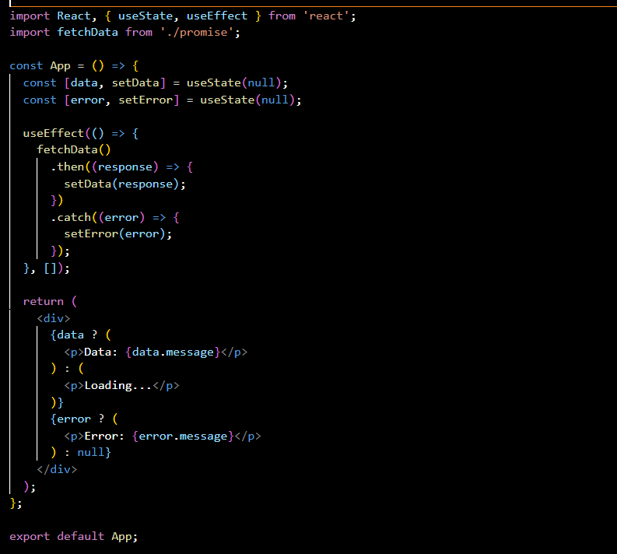

In above given code it’s showing handling the promises.

Q4. Use fetch method for calling an api

Ans. The JavaScript Fetch API is a modern interface use to fetch for resources from a server. This is achieved by sending an HTTP request to the server from the web browser.

The Fetch API includes a fetch() method, which starts the process of fetching information from any web server, and working with the information fetched.  
Using the fetch() method, we can receive data from a server, and even post data to the server.

Syntax: fetch(URL, options)

Q5. Display all the product from the api in your HTML page.

Ans.

